**Zhumagali Kanat IT2-2003**

**Lab4. Creating Procedures**

1. Create at least 4 procedures for your database. You may use the anonymous blocks you created in Lab 2 as a basis.
2. At least 3 procedures must be with parameters.
3. During the defense you must show the execution of the procedures.

create or replace procedure print_movies is

begin

for sal_record in (select movie_id, film_name, duration, year_of_release from movie where YEAR_OF_RELEASE > 2000 order by year_of_release asc) loop

dbms_output.put_line('Movie id : ' || sal_record.movie_id || ' Film name : ' || sal_record.film_name || ' Duration: ' || sal_record.duration || ' Year of release: ' || sal_record.year_of_release);

end loop;

end;

execute print_movies;

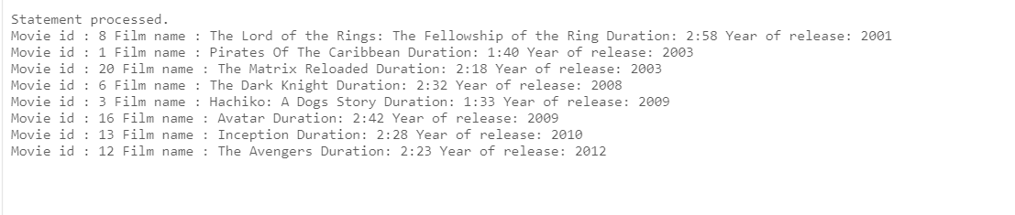

create or replace procedure mov_id (

m_id in movie.movie_id%type,

m_name out movie.film_name%type,

m_duration out movie.duration%type,

m_year out movie.year_of_release%type

) is

begin

select film_name, duration, year_of_release into m_name, m_duration, m_year from movie where movie_id = m_id;

end mov_id;

declare

m_name movie.film_name%type;

m_duration movie.duration%type;

m_year movie.year_of_release%type;

begin

mov_id(4, m_name,m_duration,m_year);

dbms_output.put_line('Movie name: ' || m_name || ' duration: ' || m_duration || ' year of release: ' || m_year);

end;

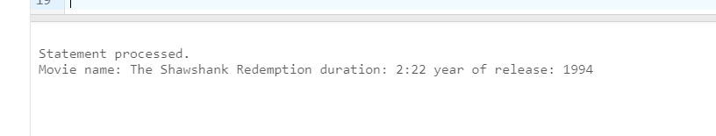

create or replace fetch_genre_movies (my_genre in genre.genre_name%type ) IS

cursor genre_cursor is select genre_id, genre_name from genre where genre_name = my_genre;

cursor movie_g_info(g_id NUMBER) IS

select m.movie_id, m.film_name, m.year_of_release from movie m join movie_genre mg on mg.movie_id = m.movie_id where mg.genre_id = g_id;

genre_rec genre_cursor%ROWTYPE;

movie_genre_info_rec movie_g_info%ROWTYPE;

begin

for genre_rec in genre_cursor loop

DBMS_OUTPUT.PUT_LINE(genre_rec.genre_id || ' Genre name: ' || genre_rec.genre_name);

foor movie_genre_info_rec IN movie_g_info(genre_rec.genre_id) LOOP

DBMS_OUTPUT.PUT_LINE(

'Movie id: ' || movie_genre_info_rec.movie_id ||

' Film name: ' || movie_genre_info_rec.film_name ||

' Year of release: ' || movie_genre_info_rec.year_of_release

);

end loop;

end loop;

end fetch_genre_movies;

execute fetch_genre_movies('Adventure')

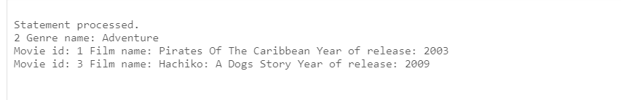

create or replace procedure get_bb(my_b in finance.budget%type) is

type movie_fin_info is record(

movie_id movie.movie_id%type,

film_name movie.film_name%type,

budget finance.budget%type,

income finance.income%type

);

m_info movie_fin_info;

cursor fin_cursor is

select m.movie_id, m.film_name, f.budget, f.income

from movie_fin mf

join movie m on mf.movie_id = m.movie_id

join finance f on mf.fin_id = f.fin_id;

begin

for fin_record in fin_cursor loop

m_info := fin_record;

if to_number(m_info.budget) > my_b then

dbms_output.put_line('Film name: ' || m_info.film_name ||

' has a budget: ' || m_info.budget ||

' and its income: ' || m_info.income);

else

dbms_output.put_line(m_info.film_name ||

' has a budget less than ' || my_b);

end if;

end loop;

end;

execute get_bb(15000);

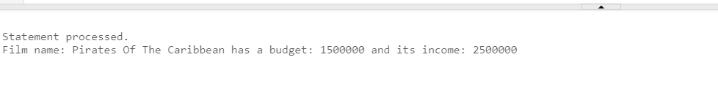

Questions:

1. Define a procedure in PL/SQL
2. Describe the functionality of procedures
3. What types of parameters exist?
4. Explain the functionality of IN parameters
5. Explain the functionality of OUT parameters
6. Explain the functionality of IN OUT parameters
7. What are formal parameters?
8. What are actual parameters?
9. What types of notations for passing actual parameters exist in PL/SQL?
10. Describe positional notation for passing actual parameters
11. Describe named notation for passing actual parameters
12. Describe mixed notation for passing actual parameters